PROPOSAL #1 FOR QSC FALL RETREAT 2020
JUDY LILLY, INSTRUCTOR judylilly@sc.rr.com

MAGNIFICENT MAGNOLIA 15 hours
This exciting class offers instruction in perspective and value. The beauty of the close-up magnolia is achieved by using a variety of fabrics in different scale and value and is enhanced by thread painting and beading. This flower is beautiful in any color as long as there is a wide range of values. Thread painting and finishing techniques will also be covered.
$10. Pattern fee (my original pattern)

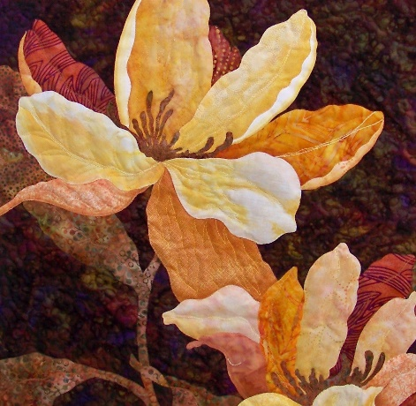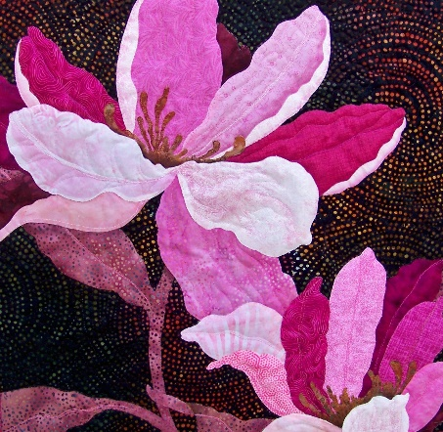

SUPPLY LIST:
Sewing machine in good working order with ¼” foot, open toe
or zig zag foot and free motion foot
Basic sewing kit: pins, sharp scissors and paper scissors, seam
ripper, stiletto, marking pencils, etc.
Monofilament thread in both clear and smoke
Lightweight bobbin thread (#50 or #60)
#70 Microtex machine needles
Black fine Sharpie
1 yard Wonder Under (no substitutes, please)
18” square tracing vellum (Golden threads paper)
18” square dark background fabric
18” squares Totally Stable stabilizer, batting and backing fabric
1/3 yard fabric for binding
2 fat quarters each of 6 values: #1 light; #2 med. lt; #3, lt.
medium; #4 medium; #5 med. dark; #6 dark. These should
all be from one color family!
1 fat quarter green for leaves, stem and foliage
8” square of interesting dark fabric for magnolia centers
Embroidery weight threads to match chosen fabrics

